POSTGRESQL QUERIES & RESULTS OF PIZZA SALES ANALYSIS
- Create Table
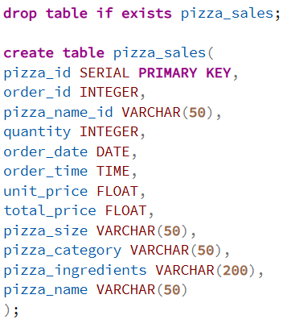

- Import Table
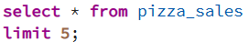
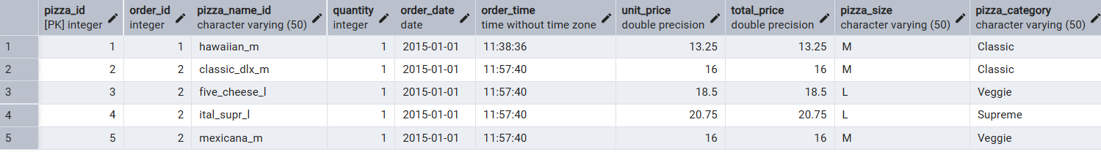

- Key Performing Indicators (KPI’s)

- Total Revenue –

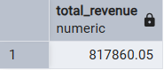

- Average Order Value -

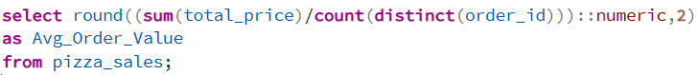
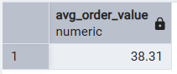

- Total Pizzas Sold -
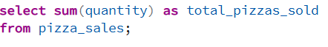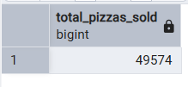

- Total Order –

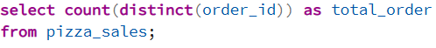
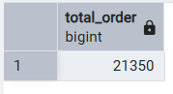

- Average Pizzas Per Order –
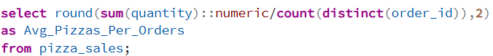
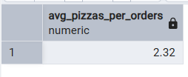

- Other Business Requirements

- Daily Trend for Total Order – 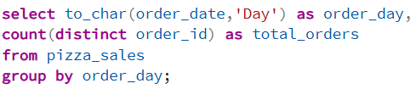
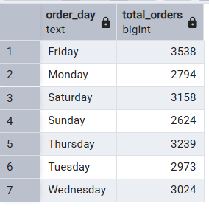
- Hourly Trend for Order– 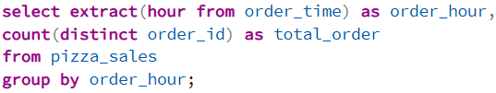
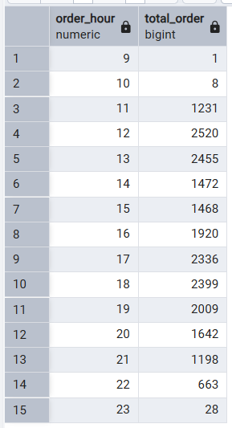

- Percentage of Sales by Pizza Category–
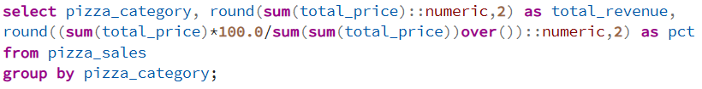
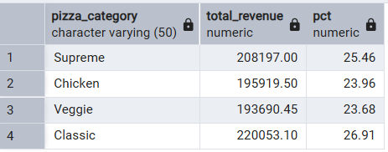

- Percentage of Sales by Pizza Size–
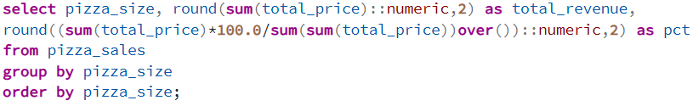
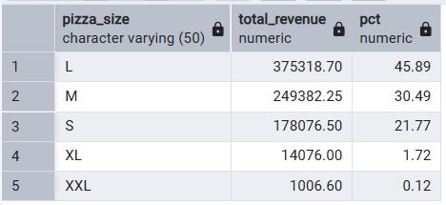

- Total Pizzas Sold by Pizza Category–
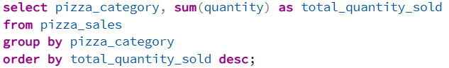
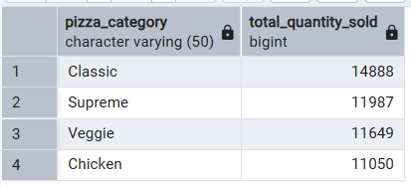

- Top 5 Best Sellers by Total Pizzas Sold–
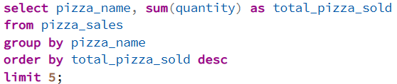
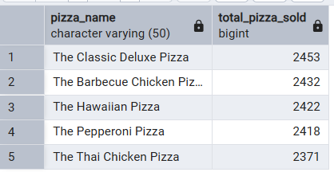

- Bottom 5 Worst Sellers by Total Pizzas Sold–
